1. Setup jenkins CICD pipeline using freestyle job using Docker containers using below code. <https://github.com/betawins/hiring-app.git>

Stages:

1) Git Clone

2) Sonarqube Integration

3) Maven Compilation

4) Nexus Artifactory

5) Slack Notification

6) Deploy On tomcat

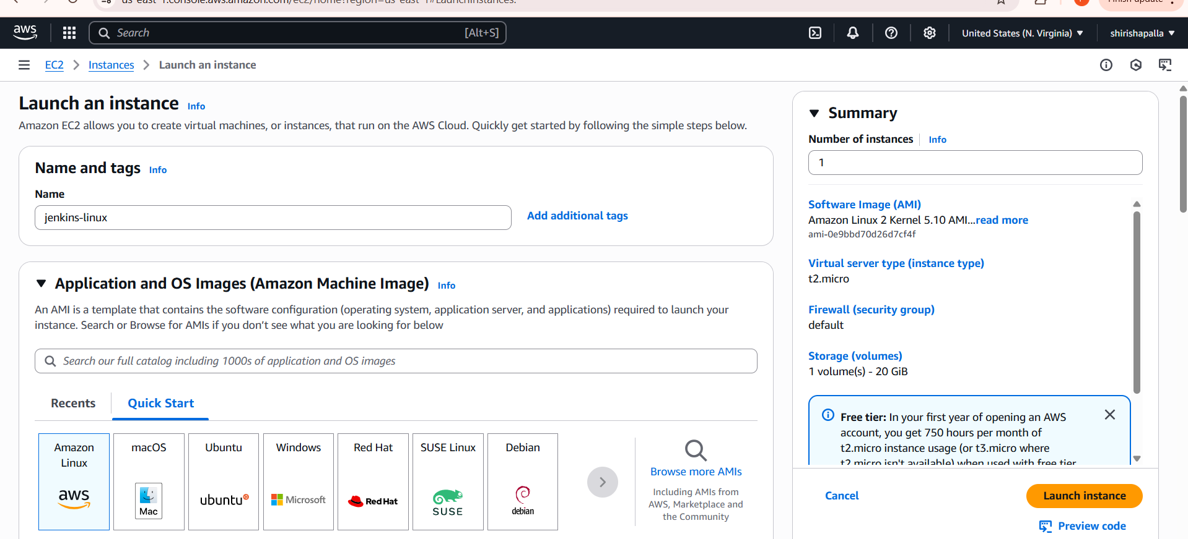

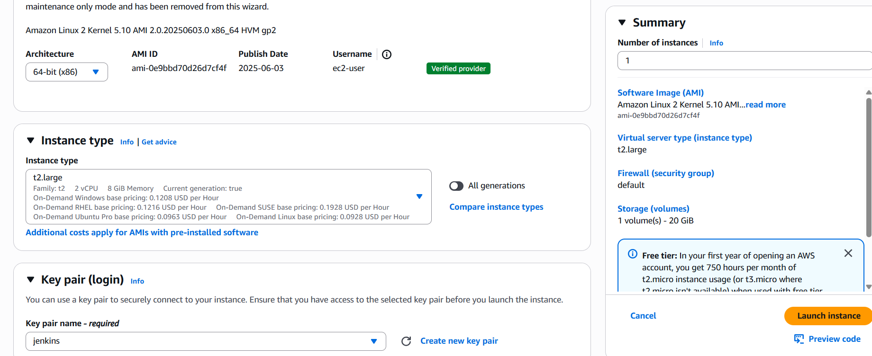

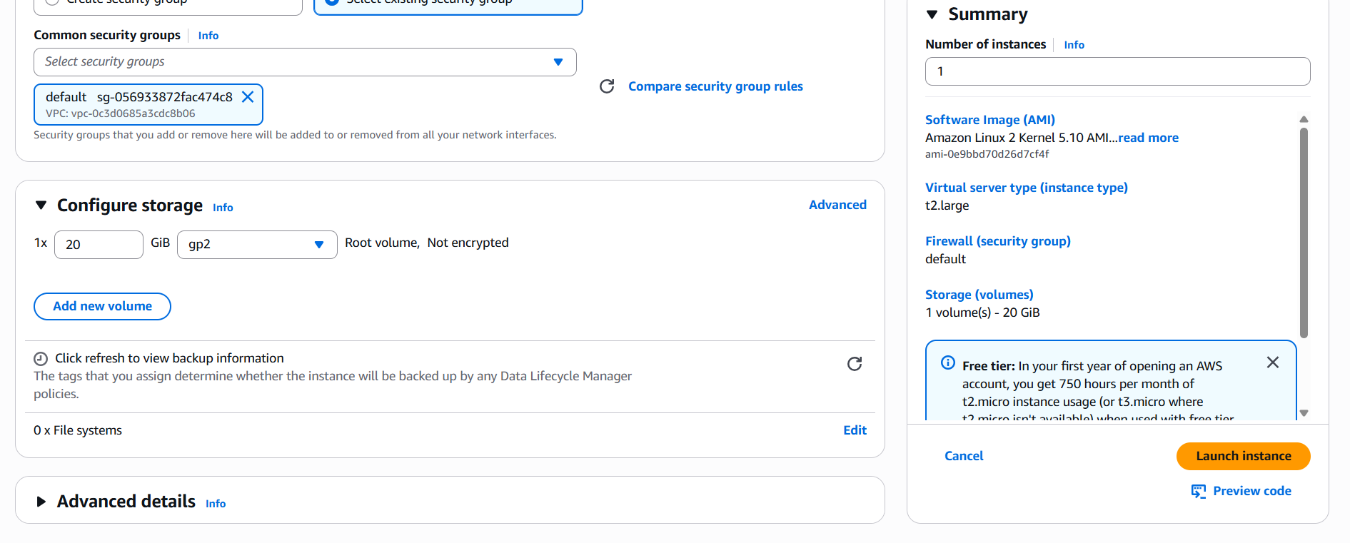

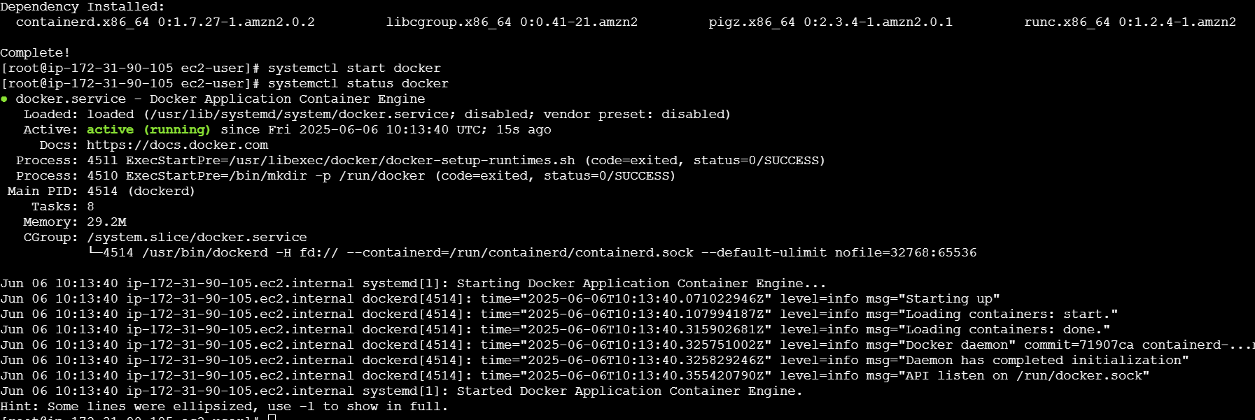

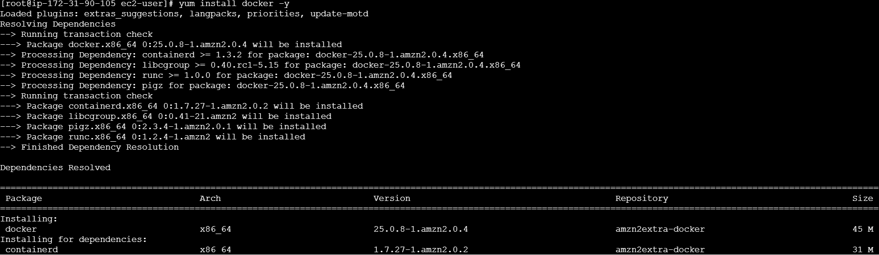





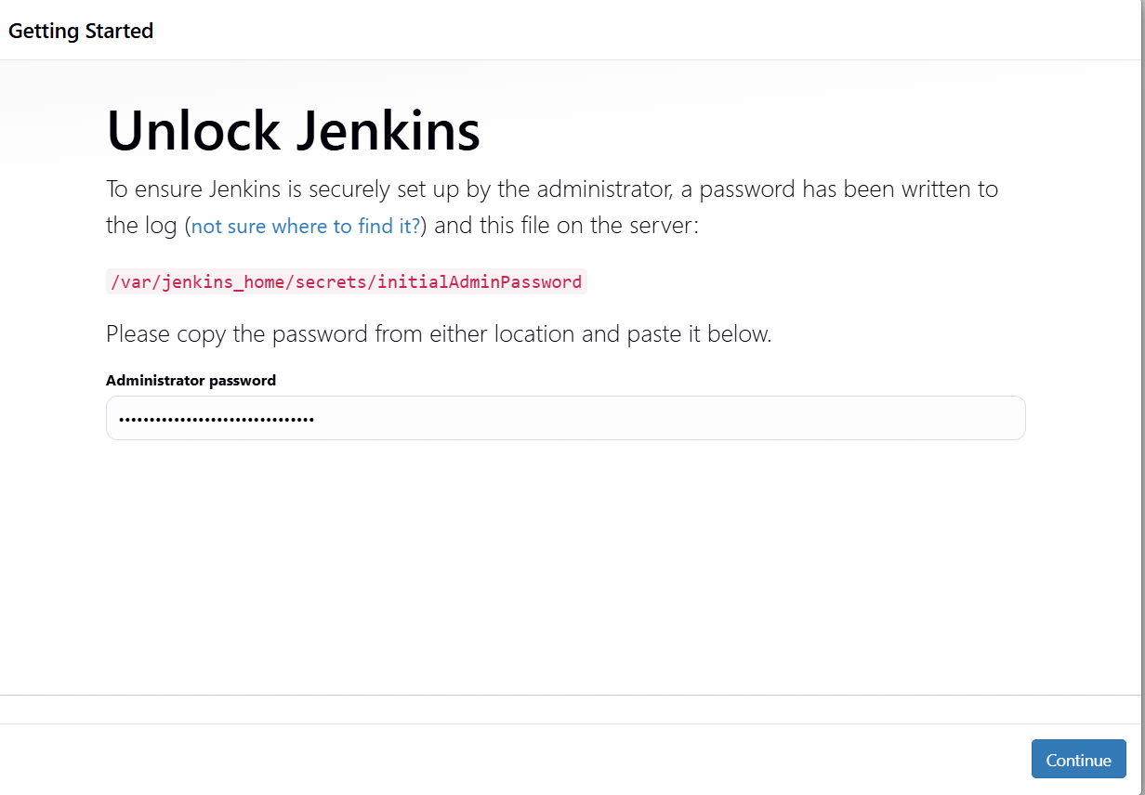

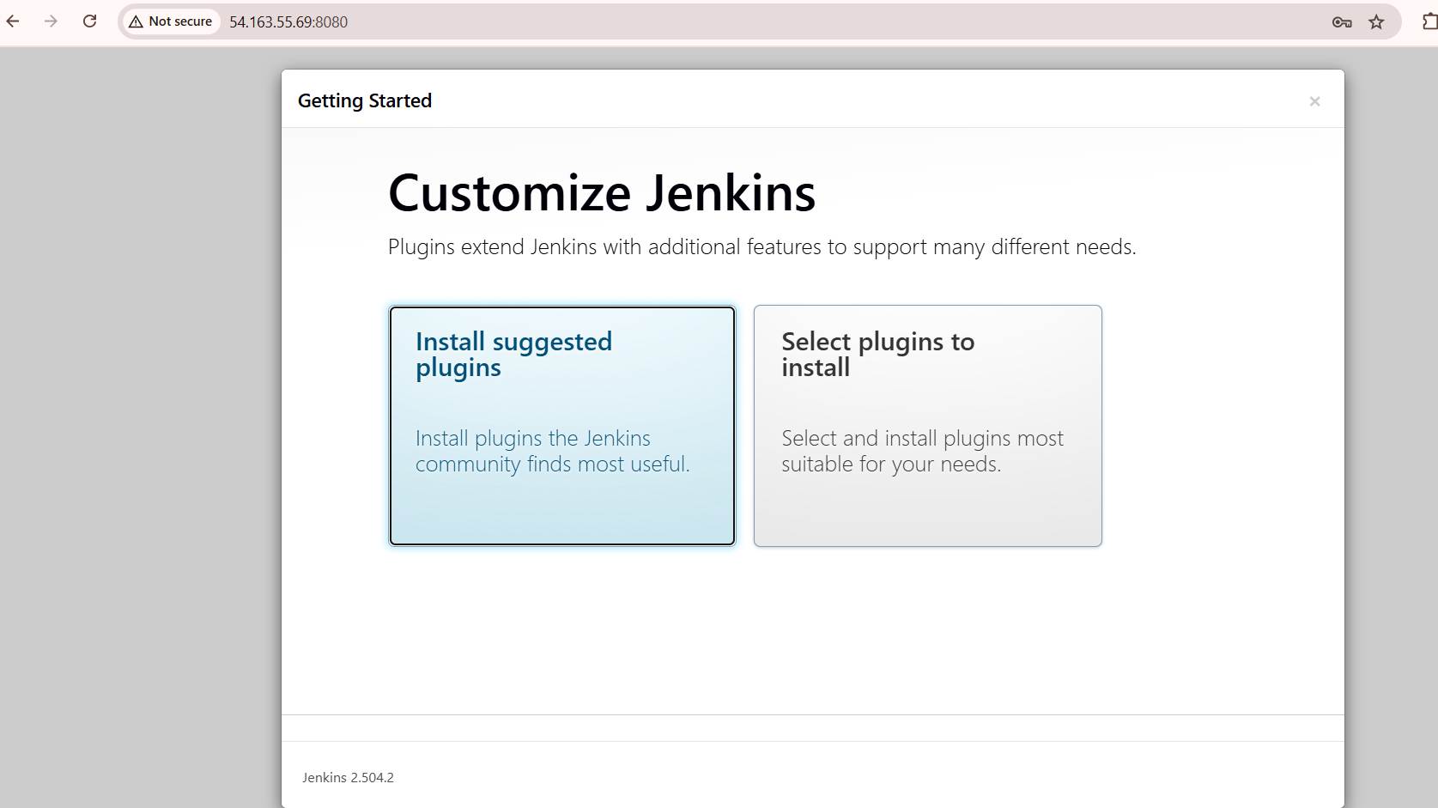

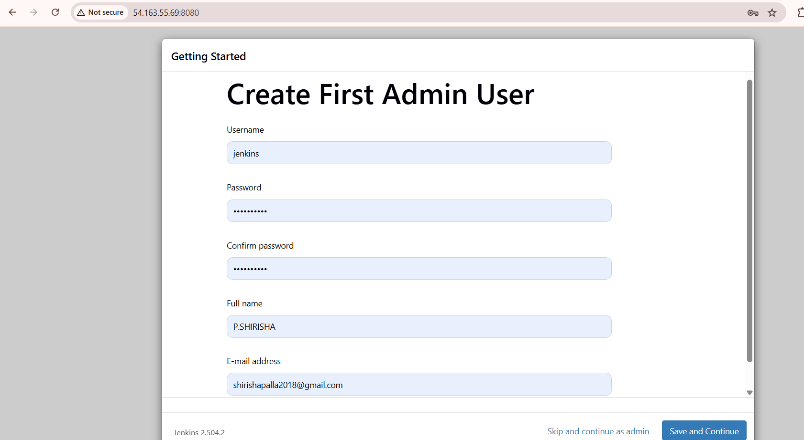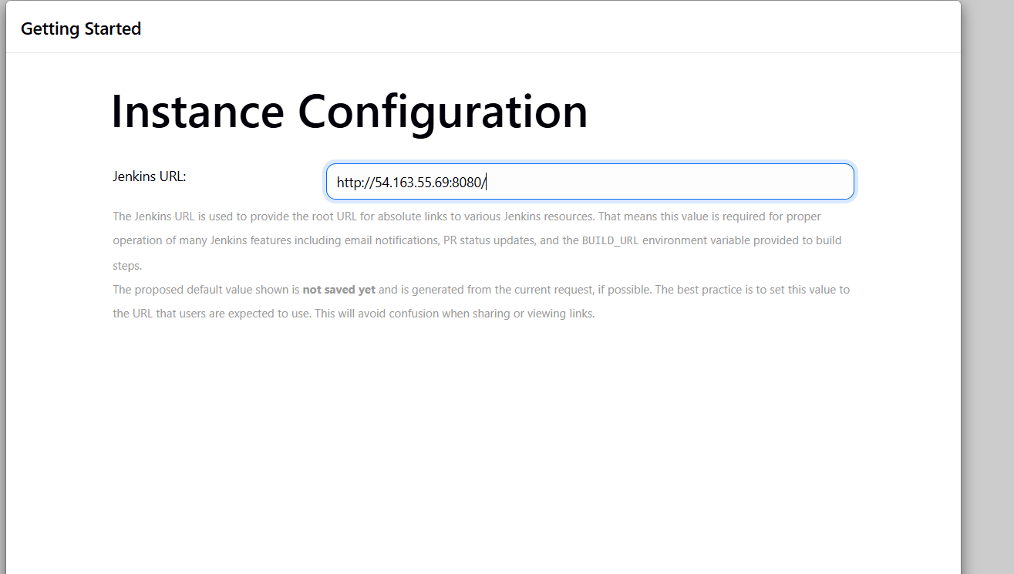

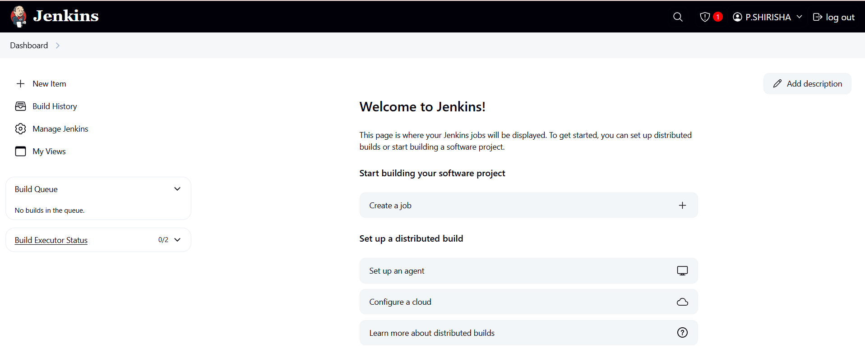

Create new instance

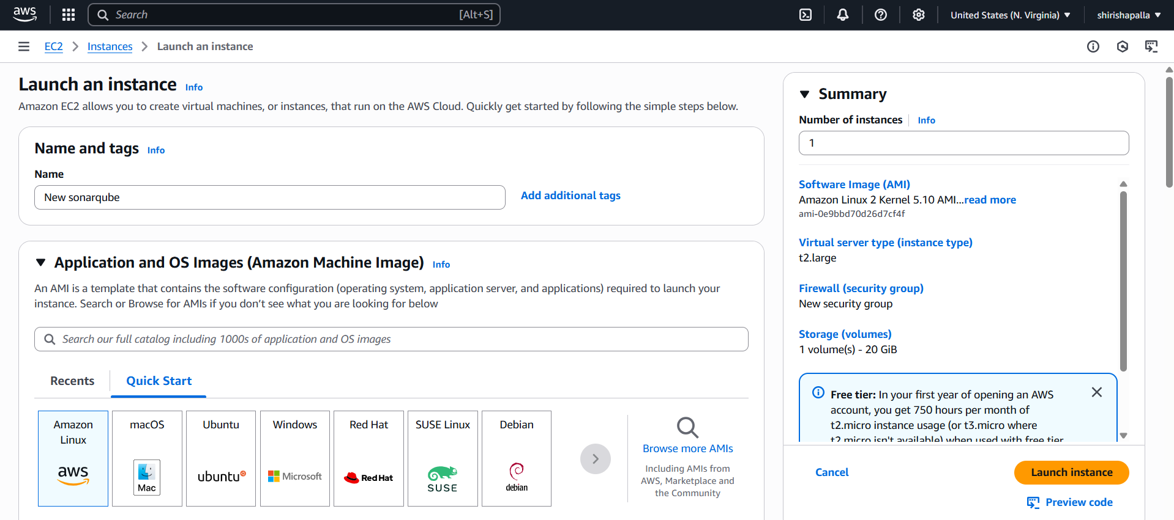

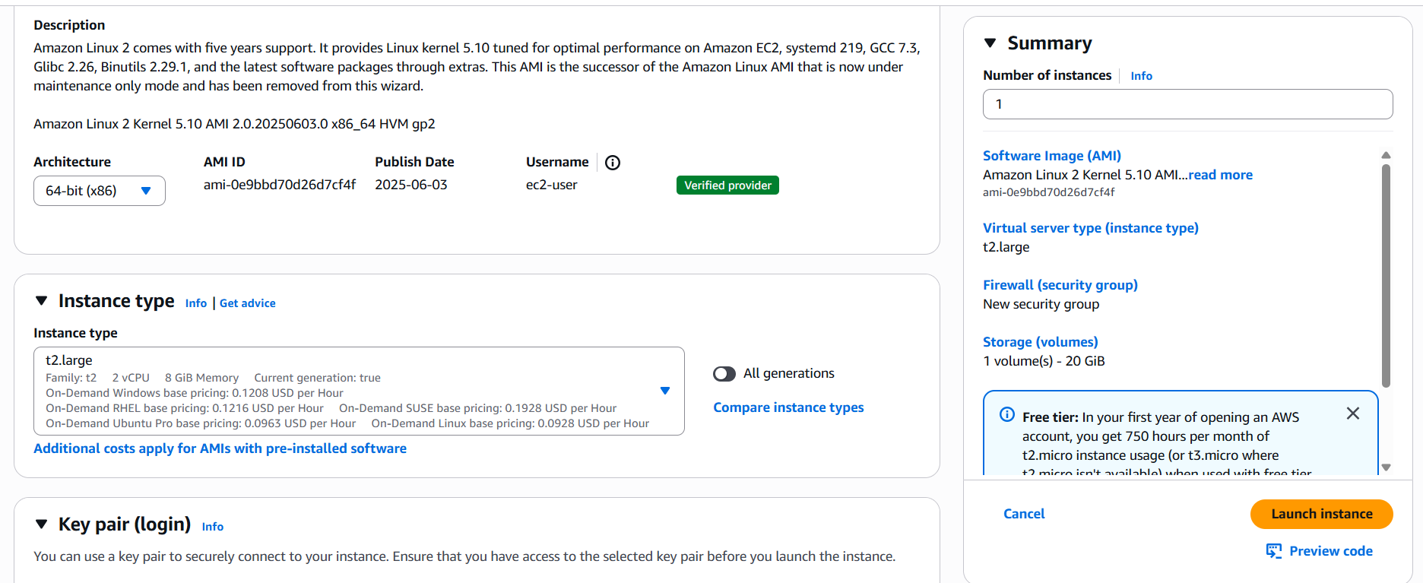

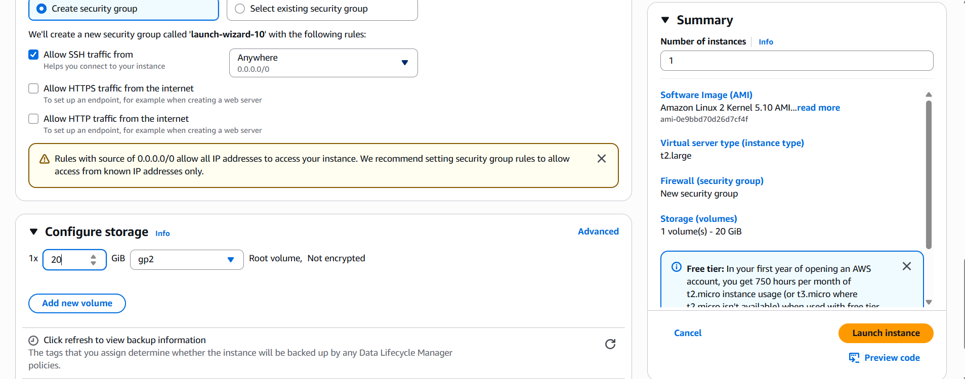

2) Setup a jenkins CICD pipeline using Declarative pipeline using feature-1.1 branch. <https://github.com/betawins/sabear_simplecutomerapp/tree/feature-1.1>

stages:

1) Git Clone

2) Sonarqube Integration

3) Maven Compilation

4) Nexus Artifactory

5) Slack Notification

6) Deploy On tomcat

3) Setup a jenkins CICD pipeline using Scripted pipeline using feature-1.1 branch. <https://github.com/betawins/sabear_simplecutomerapp/tree/feature-1.1>

stages:

1) Git Clone

2) Sonarqube Integration

3) Maven Compilation

4) Nexus Artifactory

5) Slack Notification

6) Deploy On tomcat

4) Write sample skeleton of pipelines.

5) Create a parameterized job in jenkins. <https://github.com/betawins/spring3-mvc-maven-xml-hello-world-1.git>

6) Setup one slave machine for jenkins.